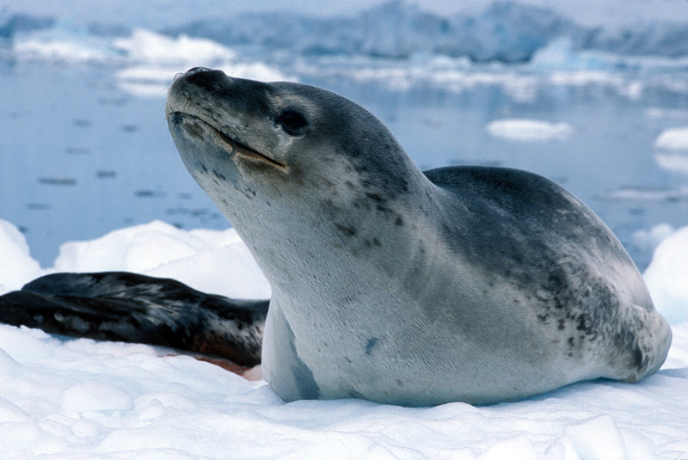

Leopard Seals

## Female leopard seals are larget than the male. They can reach weights of 590 kilograms (1300 pounds), and grow to lengths of up to three meters (10 feet. They propell themselves through the water at speeds of up to 25 miles per hour.Leopard seals do not stay with others for that long.Generally, they hunt alone and are typically never seen with more than one or two other individuals at a time.